<http://blog.teamtreehouse.com/accepting-speech-input-html5-forms>

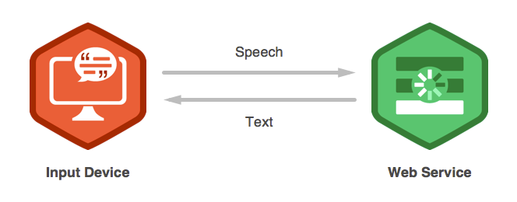

The browser relies on an external service to handle speech-to-text conversion. The recording of your voice is sent to this service which then analyses the audio and constructs a textual representation. The text is then sent back to the browser which populates the <input>element to complete the process. Many speech-to-text services incorporate machine-learning algorithms that allow them to get more accurate over time.

**Note:** A side effect of using an external service to handle speech-to-text is that you will need an internet connection for speech input to work. This is something to keep in mind if you plan for your web application to work offline.

The Chrome browser relies on Google’s proprietary speech recognition technology to provide the functionality behind x-webkit-speech. Google has had a team working on speech recognition and natural language processing for a long time. It’s this team that’s been responsible for developing the complex systems needed to provide a reliable speech-to-text service for products like Google Translate and Voice Search.